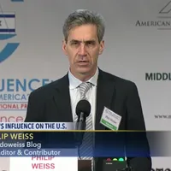
Save the Date !!

An Afternoon with Philip Weiss*
A journalist, a Jew, anti-Zionist

Topic: “From the Two-State Solution to the One State Reality: The Relationship Between Israel and Palestine.”

Phil Weiss: “The U.S. establishment is beginning to acknowledge the death of the two-state solution. The struggle now is for equal rights in one state.”

Sunday, October 22 from 2:30 - 4:00 p.m.
Presentation to be followed by Q&A.
At the Friends Center, 1501 Cherry Street, Philadelphia
The program will be hybrid (in-person and virtual)

*Philip Weiss founded Mondoweiss as a personal blog in 2006. It has grown to be a unique, independent website devoted to informing readers about developments in Israel/Palestine and related US foreign policy. The website publishes original on-the-ground reporting, analysis by scholars, and personal stories. Mondoweiss is committed to high journalistic standards of documentable evidence and reliable sourcing.

This event is made possible by tax deductible contributions to Mondoweiss at ________
Everyone is welcome! If you are able, we hope you might consider a donation of: $10 to $100. Thank you!

Sponsored by: Christian-Jewish Allies for a Just Peace for Israel/Palestine;
Philadelphia Yearly Meeting, and the American Friends Service Committee.

